Gelatine hydrogels, 3% w/V, crosslinked with TGM
Compression test for gelatine gels
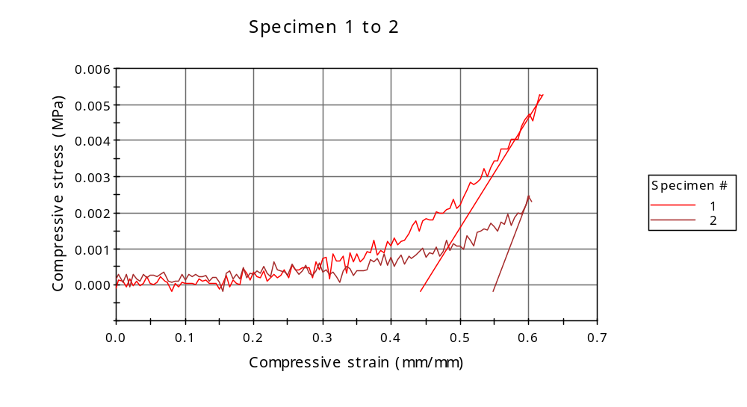
Graph 2
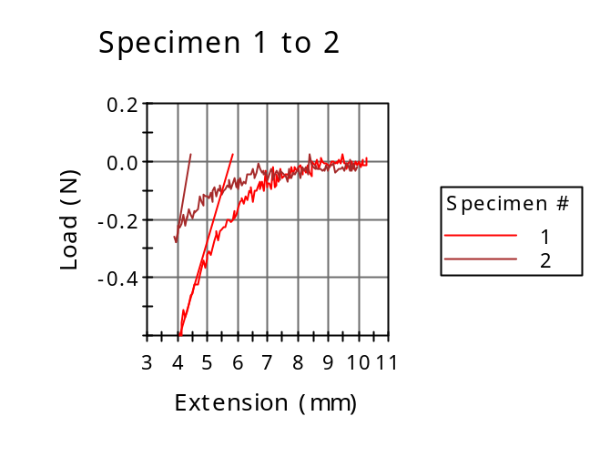

Dimension: Geometry | Circular
Dimension: Diameter | 12.00000 mm
Dimension: Anvil height | 10.00000 mm
Notes: Specimen note 1 | Cylindrical sample compression

 | Diameter  (mm) | Specimen label | Axial Gauge Length (Strain Source)  (mm)
1 | 12.00000 |  | -10.00000
2 | 12.00000 |  | -10.00000
Mean | 12.00000 |  | -10.00000
Standard Deviation | 0.00000 |  | 0.00000
Coefficient of Variation | 0.00000 |  | 0.00000

 | Anvil height  (mm) | Compressive load at Break (Standard)  (N) | Load at Break (Standard)  (N)
1 | 10.00000 | 0.59746 | -0.59746
2 | 10.00000 | 0.27755 | -0.27755
Mean | 10.00000 | 0.43750 | -0.43750
Standard Deviation | 0.00000 | 0.22621 | 0.22621
Coefficient of Variation | 0.00000 | 51.70519 | -51.70519

 | Load at Yield (Zero Slope)  (N) | Maximum Slope (Automatic Young's)  (MPa/mm/mm) | Modulus (Automatic)  (MPa)
1 | -0.02732 | 0.03076 | 0.02361
2 | -0.03950 | 0.05005 | 0.01121
Mean | -0.03341 | 0.04041 | 0.01741
Standard Deviation | 0.00861 | 0.01364 | 0.00877
Coefficient of Variation | -25.77361 | 33.75847 | 50.36043

 | Compressive load at Yield (Zero Slope)  (N) | Extension at Yield (Zero Slope)  (mm) | Compressive strain at Break (Standard)  (mm/mm)
1 | 0.02732 | 9.62983 | 0.61517
2 | 0.03950 | 8.94452 | 0.60010
Mean | 0.03341 | 9.28717 | 0.60763
Standard Deviation | 0.00861 | 0.48459 | 0.01066
Coefficient of Variation | 25.77361 | 5.21783 | 1.75435

Compressive stress at Break (Standard)
(MPa)
1 | 0.00528
2 | 0.00245
Mean | 0.00387
Standard Deviation | 0.00200
Coefficient of Variation | 51.70519

